Flix2You Database Design Enhancement Plan

IST210   
Instructor : Gary Heberling   
**Team_18**   
Penn State World Campus  
DECEMBER 11, 2015

|  |  |
| --- | --- |
| **Name** | **Title** |
| Samuel Skupien | Project Manager |
| Lindsay Klaes | Quality Assurance Specialist |
| Shyamkumar Patel | Programmer |
| Sujay Kallamadi | Data Analyst |

Table of Contents

**SECTION 1.0** **EXECUTIVE SUMMARY** 4

**SECTION 2.0** **PROJECT OVERVIEW** 5

**2.1 Scope of Work** 5

**SECTION 3.0** **PROJECT MANAGEMENT** 8

**3.1 PHASE 1 & 2** 8

**3.2 PHASES 3, 4 & 5** 9

**3.3 Project Timeline** 10

**3.4 Major Deliverables** 10

**3.4.2 Phase II – User Analysis:** 10

**3.4.2 Phase III – Database Organization and Development:** 11

**3.4.4 Phase IV – Testing & Implementation** 12

**3.4.5 Phase V – Sign Off** 12

**3.5 Project Resources and Budget Allocation** 13

**3.5.1 Flix2You Support** 13

**3.5.2 Team 18 Support** 13

**3.6 Definitive Roles and Salary** 13

**3.7 Budget Allocations** 14

**3.7.1 Total for Project Resources** 14

**3.7.2 Total for Project Expenditures** 14

**SECTION 4.0** **USER ANALYSIS** 15

**4.1 Users:** 15

**4.1.1 Tier 3:** 15

**4.1.2 Tier 2:** 15

**4.1.3 Tier 1:** 16

**4.2** **Database Access:** 16

**4.2.1 In Tier 3:** 16

**4.2.2 In Tier 2:** 16

**4.2.3 In Tier 1:** 16

**SECTION 5.0 ORGANIZATION OF DATA** 17

**5.1 Customers table from the existing database:** 17

**Diagram 5.1** 18

**5.3 Movies table from the existing database:** 18

**Diagram 5.2** 19

**5.4 The SQL queries of the new or modified database tables:** 19

**5.5 Sample Data Entry:** 20

**Diagram 5.3 - Testing data entry for Customer Information:** 21

**Diagram 5.4 - New ERD for database** 22

**SECTION 6.0 DATABASE ADMINISTRATION** 23

**6.1 Database Backup and Recovery:** 23

**6.1.1 Option 1** 23

**6.1.2 Option 2** 23

**6.1.3 Option 3** 23

**6.2 Data Access and Security:** 24

**6.2.1 Access Control: Customers and Employees** 24

**6.2.2 Security** 24

**6.3 Dataload:** 25

**SECTION 7.0 DATABASE DASHBOARD AND ANALYTICS** 26

**Graphic 7.1** – *homepage of the Flix2You website.* 26

**Graphic 6.2** - *An example for visual representation of customer information, movie genre, quantity per format type information presented in the dashboard of the website. This page is only accessible by the executive personnel of the company.* 28

**Graphic 6.3** – *download page for the sales information of movie rental.* 29

**SECTION 8.0 LEGAL ISSUES** 30

**8.1 PRIVACY POLICY** 30

**8.1.1 Information Collection, Use and Sharing** 30

**8.1.2 Information Security** 30

**8.1.3 System Updates** 31

**8.1.4 User Registration** 31

**8.1.5 Orders** 31

**8.2 TERMS AND CONDITIONS OF USE** 31

**8.2.1 REFUNDS** 31

**8.2.2 CONSEQUENCE OF VIOLATIONS** 31

**SECTION 9.0 REFERENCES** 32

# **SECTION 1.0 EXECUTIVE SUMMARY**

Our team has reviewed in detail the Flix2You Company’s history, expectations and enhancement interests to improve the current company database. Team_18 has compiled a detailed plan that we have tailored to meet your specific business model and capture your interest to choose our model.

Our plan outlines a specific project timeline and detail in cost evaluation, personnel requirements, user analysis, organization of data, data administration, database dashboard and analytics and legal issues.

Our team has looked closely at the current structure and system requirements to properly test and determine the changes and implement a detailed plan that can be found in the preceding documentation. Project milestones are identified and mark intention and execution to ensure standards are met.

We guarantee our product, services and time will produce a highly secure, efficient and user-friendly database that supports the current infrastructure and expands to enhance company growth and expectations. We are eager to begin work with Flix2You to create an elegant and simple solution for all your database needs. We are positive that our approach to your existing problems will greatly benefit your company and your 20 million users. If you choose to accept this proposal please contact us no later than December 18, 2015. Thank you for your time and consideration.

# **SECTION 2.0 PROJECT OVERVIEW**

To complete the Flix2You project, our company has proposed a list of requirements needed in order to ensure satisfactory deliverables. This includes, but is not limited to: personnel and their associated costs, planning, building, testing and implementing software, system requirements and a comprehensive list of specifications.

This project plan will contain six subject areas: the project scope, a project timeline, a list of project deliverables, a list of major milestones, project resources and a budget.

## **2.1 Scope of Work**

First our team will conduct a user analysis to determine who will need to add, update and manage stored data in the Flix2You’s repository. We will conduct interviews and observations with the companies DBA’s, programmers and other staff that needs direct access to the data. We will need to determine which Flix2You staff will have read, write and execute permissions in the database. The user analysis interviews will also help us to determine what other features will be necessary for Flix2You’s unique database. It should be noted that site visitors will not have access to this information, and standard security protocol and training will be implemented.

In addition to establishing basic user privileges, we will be determining who owns the ability to change the level of access that a user is granted. Furthermore, we will establish what the process will be to make these changes as well as determine a security hierarchy to ensure data integrity.

We will analyze the existing database and identify the relationships that are shared between all the entities and their attributes. We understand the current database was purchased as a “one size fits all” piece of software, which was modified by a previous consulting group. We are eager to build you a database that is tailored to your specific business model, and we are sure that you will be pleased with the results. Some pain points that were mentioned in your project specifications included issues with querying and dissemination of data. What we offer is the ability to take your existing database schema, entities, relationships and cardinalities and create a new diagram that will outline our database design with a guarantee of data integrity to the data that exists already.

Our usual standard operating procedure is to take a normalized approach to an existing database to produce a solution in the 3rd normal form. Once your tables are in the 3rd normal form, we will develop and document the SQL programming necessary to create at least three of the related tables in the database structure we develop. Also in addition to creating these tables we will use SQL to populate them with sample data.

We will determine the necessary roles of administrative personnel and DBA’s who will be using the system. We will also be making recommendations to update your current hardware to support your new database management system. It is understood that your current hardware consists of:

1. An HP ProLiant DL 180 G6 Intel Xeon 5500 (Motherboard/CPU)
2. Four 2 GB PC3-10600E DDR3 (Memory)
3. HP Smart Array Controller p400 (RAID Controller)
4. Two 250 GB Drives (Local Storage)
5. Three 1 TB RAID-5 drives (C: Drive)
6. Microsoft Windows 2008 R2 Standard Edition, Standard 5-User CAL (Operating System)
7. Microsoft Windows SQL Server 2008 Standard Edition (Database)

We understand your concerns regarding your backend DBMS and assure you that our solution will most definitely allow you to be “data rich AND information rich”. As far as the website is concerned we will be proposing the best platform to move your website to. Rest assured that this will be a seamless transition and will positively leverage your current infrastructure. Our goal is to give you the best possible recommendations at a cost effective price.

Data access and Security are paramount to any business dealing with customers’ personal information. Therefore it is our intention to provide you with a robust and secure system that will virtually insulate you from any outside or inside threats posed to your system. At the minimum we will require two-factor authentication for anyone attempting to access the DBMS and related information. We will provide you with an ironclad privacy statement that will allow your users to understand what information you require and how you plan to use that information. It should be noted that you as a company are allowed to sell certain metadata collected from customers to third parties. Should you choose to do this, our company will be absolved from any litigation that may stem from that. It is also our recommendation that you allow customers to understand that they surrender certain metadata when accessing your website. Your employee’s at the very least should sign Non-Disclosure agreements to not reveal any customer or intellectual property owned and maintained by Flix2You. We also strongly urge that you…. All these issues will be explored in depth later in this proposal.

We will develop a specific content management system (CMS) for Flix2You that will allow executives and administrative personnel to view and manipulate data in a dashboard layout. The CMS will allow eligible users to export progress reports of any length of time to an Excel spreadsheet or .pdf document. The CMS will also afford users a very high level of detail in determining what specific data they require reports on. This CMS will also be scalable to mobile devices such as tablets and smartphones, a necessity for any high level executive. A high level view of the information that can be accessed with the CMS includes but is most definitely not limited to:

* New Members
* Revenue
* Number of rentals
* Movie name
* Ratings
* Rental Frequency

The data query possibilities will only limited to your imagination on what you want reports on, and above all it will be simple and intuitive to use. In our experience this is achieved by grouping information alphabetically and numerically.

The legal section will cover recommended disclaimers and privacy statements that will insulate you from virtually all lawsuits. The privacy statements will cover topics including, but not limited to: how you plan on keeping the customers data private, how the customer's data will be used and an overview of the security in place to address these questions. It will also include the terms and conditions for using Flix2You’s services. These will cover topics such as: creating a purchasing policy, refund protocols and outlining penalties that result from violations of the terms and services. All other rights and privileges are at the risk of the Flix2You Company.

# **SECTION 3.0 PROJECT MANAGEMENT**

## **3.1 PHASE 1 & 2**

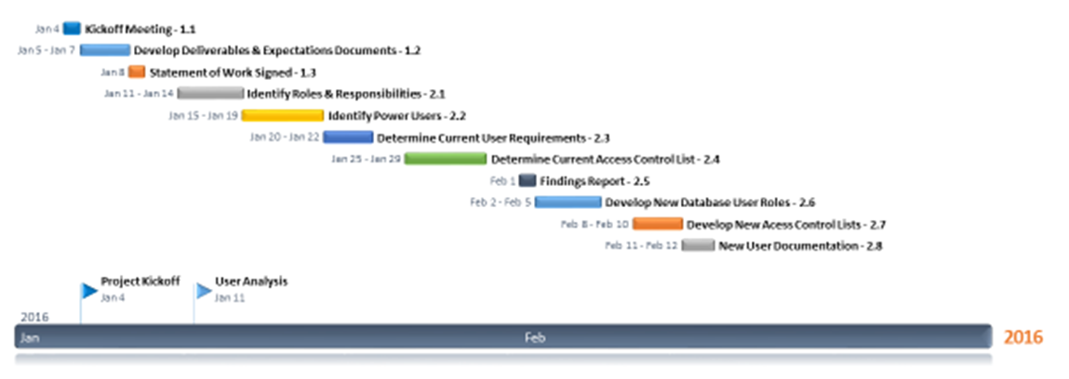

## **3.2 PHASES 3, 4 & 5**

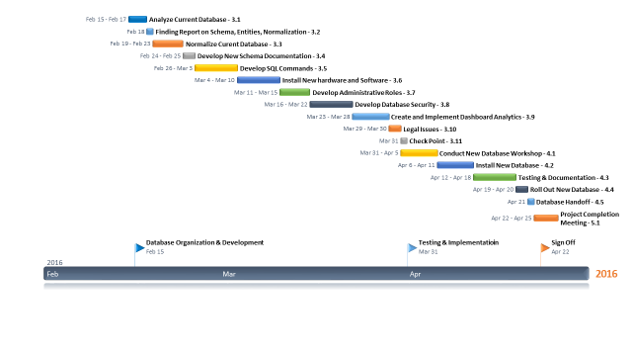

## **3.3 Project Timeline**

The project plan will consist of five phases. Phase one will be administrative duties that will need to be addressed before the project can begin. Phase two is the user analysis phase. Phase three will be database organization and development, phase four will be testing and implementation and phase five will be the project handoff. The project will begin on January 4, 2016 and will end on April 22, 2016.

## **3.4 Major Deliverables**

1. Develop and provide documentation for new database user roles and access control lists
2. Normalize current database and provide documentation for new schema and SQL commands
3. Install new hardware and software
4. Develop and provide documentation for new database administrative roles, security and dashboard analytics
5. Develop user and company legal policies and procedures
6. Install and test new database

**3.4.1 Phase I – Project Kickoff:**

1.1 Kickoff Meeting:   
A project kickoff meeting will be held with both Team 18 and Flix2You project team members. This meeting will outline the various milestones, deliverables and expectations that are to be held during the course of the project.

1.2 Develop Deliverables & Expectations Document:   
The results of the kickoff meeting will be compiled into a document that both teams have agreed upon which will cement the deliverables and expectations.

1.3 Statement of Work Signed:   
A statement of work will be signed that outlines the: deliverables, expectations, legal obligations and a business contract. This will also outline the procedure if the timeline expectations or deliverables have been altered by unforeseen circumstances and how they will impact the proposed timeline.

### **3.4.2 Phase II – User Analysis:**

2.1 Identify Roles & Responsibilities:  
We will identify the current roles and responsibilities of the various users who are able to access the database and add, update, and manage the data stored in the database.

2.2 Identify Power Users:   
We will identify specific users, such as the system administrators, who need to be able to change the access control lists.

2.3 Determine Current User Requirements:   
We will determine what certain users need to be able to accomplish in the database, such as which files they are allowed to access and the appropriate level of access control.

2.4 Determine Current Access Control List:   
This will be a fully compiled list of all current database users and their abilities to read, write and execute files on the database.

2.5 Findings Report:   
This report will compile all the findings of steps 2.1 to 2.4, and will be audited by both Team 18 and Flix2You for accuracy and completion.

2.6 Develop new Database User Roles:   
Since we will be changing the current schema, it will be necessary to reassign current users accordingly. Some areas they were able to access before may now be off limits to them.

2.7 Develop New Access Control Lists:   
These new access control lists’ will reflect the new user roles inside the updated database.

2.8 New User Documentation:   
This deliverable will be a complete list of user roles, access control and responsibilities within the database.

### **3.4.2 Phase III – Database Organization and Development:**

3.1 Analyze Current Database:   
We will analyze the current database to determine what can be improved.

3.2 Findings Report on Schema, Entities and Normalization:   
This report will include information on the database in its current state.

3.3 Normalize Current Database:   
We will normalize the database to the third normal form. This will avoid data redundancy and unnecessary entities and attributes.

3.4 Develop New Schema Documentation:   
This document will reflect the structure of the new database normalization.

3.5 Develop SQL Commands:   
We will develop SQL commands that will allow authorized users to control data in the database.

3.6 Install New Hardware and Software:  
Based on recommendation and agreement we will update the necessary hardware and software in order to increase efficiency and optimization.

3.7 Develop Administrative Roles:   
Based on user requirements we will assist in setting up new administrative roles.

3.8 Develop Database Security:   
We will develop and implement database security measures.

3.9 Create and Implement Dashboard Analytics:   
We will develop a dashboard that management will be able to view and query information from.

3.10 Legal Issues:   
This will encompass the various legal legislation that Flix2You and consumers of Flix2You will have to abide by.

3.11 Check Point:   
We will make sure that all implementation thus far are correct according to the statement of work.

### **3.4.4 Phase IV – Testing & Implementation**

4.1 Conduct New Database Workshop:   
We will conduct a workshop in order to familiarize users with the new database.

4.2 Install New Database:  
We will install the new database on Flix2You servers in order to begin testing.

4.3 Testing & Documentation:   
We will thoroughly test and document any necessary changes or issues with the new database.

4.4 Rollout New Database:   
After testing is complete the new database will go live.

4.5 Database Handoff:   
We will conduct a database handoff with the Flix2You database administrators.

### **3.4.5 Phase V – Sign Off**

5.1 Project Completion Meeting:   
We will hold a project completion meeting with key members of both project management teams to ensure that all expectations were met and that the agreed upon contract was fulfilled.

## **3.5 Project Resources and Budget Allocation**

To complete this plan of action, the following team should be assembled both from Flix2You and Team 18 companies in order to achieve the project goal. These teams should be set up accordingly throughout the duration of the project.

### **3.5.1 Flix2You Support**

One of each of the following roles should be filled:

* Project Manager
* Database Administrator
* Data Analyst
* Quality Assurance Specialist

### **3.5.2 Team 18 Support**

One of each of the following roles should be filled:

* Project Manager
* Database Administrator
* Data Analyst
* Quality Assurance Specialist

Additional support:

* Programmer – should have a minimum of 2

## **3.6 Definitive Roles and Salary**

**3.6.1 Project Manager**           
Oversight of all contract project milestones, budget and resource evaluation and lead for each phase. Will be the primary point of contact for collaborative efforts and issues that arise.  
**Salary: $75, 578.00**

**3.6.2 Database Administrator**Oversight of system security and access through design, implementation and rollout.   
**Salary: $64,234.00**

**3.6.3 Data Analyst**Reviews data for analysis, provides reports and reviews data for integrity throughout the phases.  
**Salary:** **$53,194.00**

**3.6.4 Quality Assurance Specialist**Signs off on verification of each deliverable with a thorough review of appropriate documentation and certification including training.  
**Salary: $49,973.00**

**3.6.5 Programmer**Updates the database tables and rewrites any necessary script to meet the business rules and align policies and procedures for use. Will be at the forefront of design issues to track and ensure completion.  
**Salary: $57,388.00**

## **3.7 Budget Allocations**

### **3.7.1 Total for Project Resources**

This includes all positions to be filled and the expected amount paid out for these resources. Allocations also include backup plan for additional resources unforeseen.  
**TOTAL for Budget: $500,000.00**

### **3.7.2 Total for Project Expenditures**

This will include the procurement fees for additional hardware and software upgrades required to accomplish project. Included in this will be any and all other expenses unforeseen.  
**TOTAL for Budget: $750,000.00**

# **SECTION 4.0 USER ANALYSIS**

**4.1 Users:**

Users considered in the Flix2You Problem will fall under one of the 3 main tiers as followed:

·         Tier 3- Upper-level management and administrative support

·         Tier 2- Mid-level management

·         Tier 1- Hourly employees (warehousing and logistics)

The organization currently has 50 employees. Currently, there are 12 employees in Tier 3, 18 employees in Tier 2, and 20 employees in Tier 1. Within this hierarchy, each tier allocates different privileges in respect to database access.

Within these tiers are various detailed positions/teams as followed:

**4.1.1 Tier 3:**

**Database Administrator:**

The DBA (database administrator) manages the various positions available in Tier 3. They verify that Tier 3 operations are running efficiently. If issues occur, focus will be redirected to the specific role(s).

**Database Backup Operator:**

Maintaining logs and backups for everyday tasks is essential to provide easy debugging and data recovery. If issues occur, whether with code or hardware failure, it can be easily analyzed and resolved.

**Database Security Officer:**

Security plays a very important role within the database. If a breach occurs in the database, confidential data may be compromised and as well as the overall integrity of the database. They also monitor appropriate access levels alongside the DBA.

**Programmers:**

The programmers create and modify the application without error. They design each component and verify that each action performed by the consumer is correct and properly implemented into the database.

**Database Network Administrator:**

The database network administrator works side-by-side with the database security officer in terms of security. An additional aspect that is focused with the network administrator would include congestion control, which monitors consumer-user interaction with the application in the network layer.

**4.1.2 Tier 2:**

**Marketing:**

The marketing team will develop strategies to obtain more customers. The purpose is to increase growth of the company in respect to popularity and the upbringing of the company image.

**Data analyst:**

Analyzes incoming data and translates it into easy to understand information. This information may be crucial to the marketing team.

**Finance:**

The main purpose of the finance team is to monitor cash flow and expenses. They will analyze different areas that require more or less money and utilize it more efficiently.

**4.1.3 Tier 1:**

**Hourly Employees:**

Hourly employees may entail warehouse, logistics, customer service, and store employees.

**4.2** **Database Access:**

**4.2.1 In Tier 3:**

Individuals will have access to read and write to the database in respect to their department, excluding the DBA. The DBA has complete full access to the database as they help with the other various roles within the level. They are responsible for granting the appropriate access level for each tier based on position and requirements therein.

**4.2.2 In Tier 2:**

Individuals will have access to read the database in respect to their department. If modification is required, they can request permission from the DBA to grant them special access.

### **4.2.3 In Tier 1:**

Individuals will have limited read and write access. This access is to be reviewed and approved by the DBA and the Database Security Officer. These hourly employee roles will have access to read specific tables that include *‘Movies’*, *‘Customer Rentals’*, *‘Customers’*, *‘Account’*, and *‘Financial Transactions’*.

# **SECTION 5.0 ORGANIZATION OF DATA**

Flix2Your is currently utilizing a generic e-commerce database solution. While this solution is functional, some improvements could be made to make the company database more efficient and less confusing. The modified off-the-shelf software will be changed to make the company’s information infrastructure more efficient in utilizing the available computing resources. This could result in consistent, easier, and faster online experience for the customers while being competitive.

The storage of inconsistent or redundant data raises performance concerns such as slow online system and sluggish transaction processing. These concerns not only affect the customers, but also affect the bottom line profits of the company. The system’s decrease in performance occurs as the result of poor implementation of the database, including unnecessary anomalies and redundant data. These anomalies and redundancy data could weaken database integrity and affect the data storage. To resolve these issues and minimize concerns, our team’s database designer reorganizing the existing database for efficiency. Although the normalization process would yield efficiency as well, we will be using an alternative method which combines benefits of normalization with faster performance. Similar to normalization, two main objectives that will be accomplished using the alternative method. The first objective will be eliminating the redundant data and the second objective will be ensuring data dependencies. Upon the completion of this process, our team expects to achieve:

1. Removal of unnecessary redundant data.
2. Reduce the amount of data stored in the database.
3. Improve maintenance of database.
4. Enable representation of certain information (or loss of information).
5. Improve system speed.

Upon the implementation of the alternative method within the company’s information system, establish dependencies that are practical, reduce non-key data dependencies, and remove transitive dependencies. The team’s database designer will begin the decomposition process by applying tests to eliminate the anomalies. These anomalies include insertion, update and deletion.

**5.1 Customers table from the existing database:**

Customers (customer_id, member_yn, membership_number, data_became_member, customer_first_name, customer_last_name, customer_address, customer_phone, customer_email, customer_dob)

**Partial Dependencies:**

(customer_id 🡪 customer_first_name, customer_last_name, customer_address, customer_phone, customer_email, customer_dob)

(customer_id 🡪 membership_number)

**Transitive Dependency:**

(membership_number 🡪 member_yn, data_became_member,)

There is partial dependencies dependency in this table, therefore this table need to be normalize. This means that we need to rearrange the table as well as create new tables. Since our solution utilizes denormalization method, in combination with alternative methods, separation of attribute will be done to implement additional features which yields faster performance and eases querying of data. The Customers tables will be separating into three separate tables named, Customers, Customer_Information, and Member_Information. This separation will yield faster performance, improved maintenance of customer information, and less querying of data. Also, our designers have broken the address attribute in the existing database into street_adderess, city, state, and zip_code. Additionally, a table called Zip_Code will be created to store city and state attributes. Doing this would help the implement proper triggers, which would help data analytics. The improved tables could be seen below, in the

**Diagram 5.1**

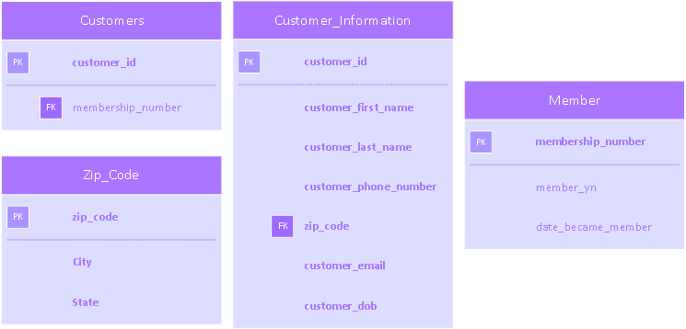

*This diagram contains Customer, Member, Zip Code, and Customer Information table.*

**5.3 Movies table from the existing database:**

Movies (movie_id, condition_code, format_type_code, genre_type_code, store_id, release_year, movie_title, movie_description, number_in_stock, rental_or_sale_or_both, rental_daily_rate, sale_price)

**Partial Dependencies:**

(movie_id 🡪 release_year, movie_title, movie_description)

(movie_id 🡪 condition_code, format_type_code, genre_type_code, store_id, number_in_stock, rental_or_sale_or_both, rental_daily_rate, sale_price)

The Movies table from the existing database has dependencies, hindering the database performance. Our database designer will separate Movies table’s attributes to reduce dependency, improve performance, and ease querying. Most of the attribute in the Movies table will stay there since they are needed for referencing to other tables. A new table, called Movie_Information, will be created for attribute that are not needed for referencing. The new tables could be seen, in the **Diagram 5.2**, below.

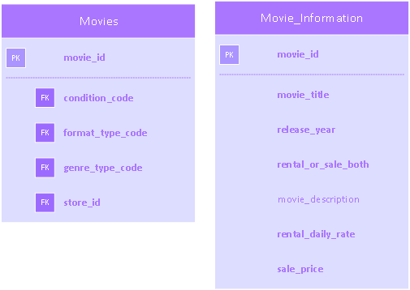

**Diagram 5.2**

*This diagram contains Movies and Movies Information tables. These tables indicate the keys and requirements of the attributes.*

**5.4 The SQL queries of the new or modified database tables:**

/* video_stores */

ALTER TABLE Video_Stores DROP COLUMN store_zip;

ALTER TABLE Video_Stores ADD zip_code int NOT NULL;

Messages: Command(s) completed successfully.

/* Customers */

ALTER TABLE Customers DROP COLUMN member_yn;

ALTER TABLE Customers DROP COLUMN date_became_member;

ALTER TABLE Customers DROP COLUMN customer_first_name;

ALTER TABLE Customers DROP COLUMN customer_last_name;

ALTER TABLE Customers DROP COLUMN customer_address;

ALTER TABLE Customers DROP COLUMN customer_phone;

ALTER TABLE Customers DROP COLUMN customer_email;

ALTER TABLE Customers DROP COLUMN customer_dob;

Messages: Command(s) completed successfully. (SQL Alter Table Statement, n.d)

/* zip_code */

CREATE TABLE Zip_Code( zip_code int IDENTITY (1,1) NOT NULL, City varchar(32) NOT NULL,

State_Initail varchar(2) NOT NULL);

Messages: Command(s) completed successfully.

/* member */

CREATE TABLE Member( member_yn varchar(32) NOT NULL, membership_number int NOT NULL,

date_became_member varchar(10) NOT NULL);

/* movies */

ALTER TABLE Movies DROP COLUMN release_year;

ALTER TABLE Movies DROP COLUMN movie_title;

ALTER TABLE Movies DROP COLUMN movie_description;

ALTER TABLE Movies DROP COLUMN rental_or_sale_or_both;

ALTER TABLE Movies DROP COLUMN rental_daily_rate;

ALTER TABLE Movies DROP COLUMN sales_price;

Messages: Command(s) completed successfully. (SQL Alter Table Statement, n.d)

/* Movie_Information  */

CREATE TABLE Movie_Information(

movie_id int IDENTITY(1,1) NOT NULL,

release_year int NOT NULL,

movie_title varchar(128) NOT NULL,

movie_description varchar(1024) NOT NULL,

rental_or_sale_or_both tinyint NOT NULL,

rental_daily_rate money NOT NULL,

sales_price money NOT NULL);

Messages: Command(s) completed successfully.

/* Customers_information */

CREATE TABLE Customer_information(

customer_id int IDENTITY(1,1) NOT NULL,

customer_first_name varchar(32) NOT NULL,

customer_last_name varchar(32) NOT NULL,

customer_address varchar(128) NOT NULL,

zip_code int NOT NULL,

customer_phone varchar(32) NOT NULL,

customer_email varchar(128) NOT NULL,

customer_dob varchar(10) NOT NULL);

Messages: Command(s) completed successfully. (SQL AUTO INCREMENT Field, n.d.)

ALTER TABLE Customer_Information ADD CONSTRAINT pk_customer_info_id PRIMARY KEY (customer_id);

ALTER TABLE Zip_Code ADD CONSTRAINT pk_zip_code PRIMARY KEY (zip_code);

ALTER TABLE Movie_Information ADD CONSTRAINT pk_movie_id_info PRIMARY KEY (movie_id);

ALTER TABLE Member ADD CONSTRAINT pk_membership_number PRIMARY KEY (membership_number);

Messages: Command(s) completed successfully.

ALTER TABLE Customers ADD  CONSTRAINT fk_membership_number_cus FOREIGN KEY (membership_number) REFERENCES Member(membership_number);

ALTER TABLE Customer_Information ADD  CONSTRAINT fk_zip_cus_info FOREIGN KEY (zip_code) REFERENCES Zip_Code(zip_code);

ALTER TABLE Video_Stores ADD  CONSTRAINT fk_zip_video_store FOREIGN KEY (zip_code) REFERENCES Zip_Code(zip_code);

Messages: Command(s) completed successfully. (SQL ALTER TABLE Statement, n.d)

**5.5 Sample Data Entry:**

SET IDENTITY_INSERT [dbo].[Zip_Code] ON

INSERT INTO [dbo].[Zip_Code] ( [zip_code], [City], [State_Initail]) VALUES (  00001, 'Johnsonvil', 'PA');

INSERT INTO [dbo].[Zip_Code] ( [zip_code], [City], [State_Initail]) VALUES (  00002, 'Smithvil', 'PA');

INSERT INTO [dbo].[Zip_Code] ( [zip_code], [City], [State_Initail]) VALUES (  00003, 'ISTville', 'PA');

SET IDENTITY_INSERT [dbo].[Zip_Code] OFF

Testing data entry for zip code

SELECT * FROM Zip_Code;

MESSAGE:

zip_code    City                             State_Initail

----------- -------------------------------- -------------

1           Johnsonvil                       PA

2           Smithvil                         PA

3           ISTville                         PA

(3 row(s) affected)

SET IDENTITY_INSERT [dbo].[Customer_Information] ON

INSERT INTO [dbo].[Customer_Information] ( [customer_id], [customer_first_name], [customer_last_name],

                                         [customer_address], [zip_code], [customer_phone],

                                         [customer_email], [customer_dob])

VALUES (  01, 'John', 'Smith', '1235 Main Street', 1, '1234567890', 'jsmith@outlook.com', '1/1/2011');

INSERT INTO [dbo].[Customer_Information] ( [customer_id], [customer_first_name], [customer_last_name],

                                         [customer_address], [zip_code], [customer_phone],

                                         [customer_email], [customer_dob])

VALUES (  02, 'Jerry', 'Onng', '1235 Time Street', 00002, '1234545120', 'jonng@gmail.com', '1/2/2011');

(SQL INSERT INTO Statement, n.d)

**Diagram 5.3 - Testing data entry for Customer Information:**

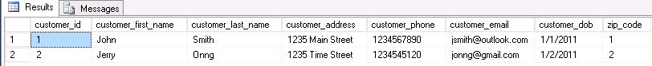

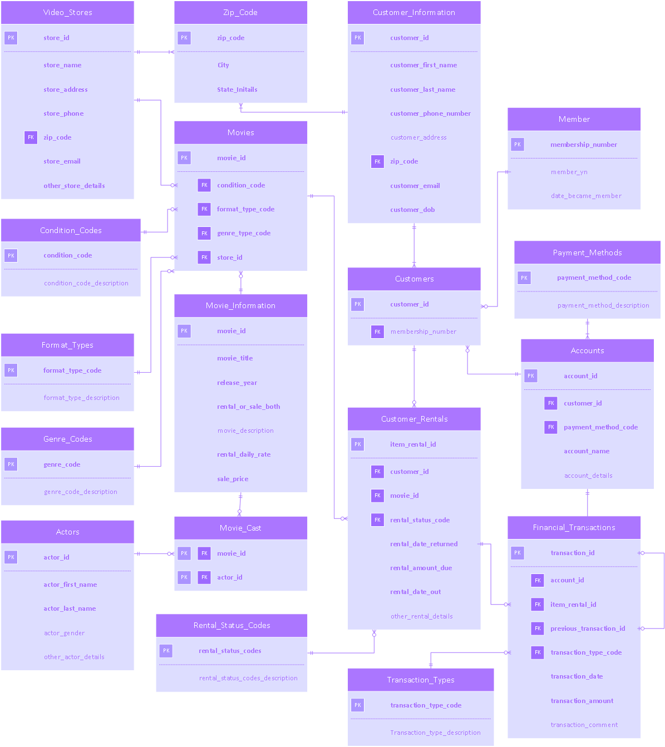**Diagram 5.4 - New ERD for database**

*Entity Relationship Diagram in Crow’s Foot Notation for the new database/data repository.*

# **SECTION 6.0 DATABASE ADMINISTRATION**

## **6.1 Database Backup and Recovery:**

Providing a backup or recovery option for any database is crucial. If any system crashes and there are no plans to recovering, data could be lost forever. There are a few options that can be considered.

### **6.1.1 Option 1**

Use and setup of RAID configuration on the individual system. From the given technical specifications, it currently has three one-terabyte drives in RAID 5. This configuration enables one disk as a parity disk, which prevents any loss of data. An advantage of this is its read speeds, as it is across several disks. If using this system for storing the videos, only an initial slowdown would occur when writing to the disks, which does not play a crucial role in this aspect. If a download option does become readily available, a different RAID configuration might be needed. One reason would include data transferring, as this might cause some load balancing issues. Another issue that might come to play is the need of more memory, as it requires more than a simple RAID 1 (cloned) configuration.

### **6.1.2 Option 2**

A second option to evaluate is having another server in a different location. This would improve steaming latency, depending on the location.

An example:

Suppose there is a user that wants to steam a movie. If there only exist one server located in California, they could get some latency issues if trying to stream from New York. If there are two servers and one has a backup in Virginia, the user would have better latency, if connected to that server, while still having a backup copy for recovery.

### **6.1.3 Option 3**

Another option and preferred option for the future would be to send the data to a third party. One immediate concern that comes up is trust. If there is no trust between the two companies, it could cause confidentiality issues. Another issue would be security. If the servers provided by the third party had low security, people could obtain/steam movies illegally.

Given these three options, at the current state of the company, it should stay how it is right now, in RAID 5. Until its user base has grown across the country, there is no need to expand just yet. When it reaches that state, expanding to option two would seem beneficial. Lastly, if it grows to an international state, it might be best to migrate only the movies to a third party world-cloud company that can be trusted. This process might take some time to research but, would provide great speeds anywhere around the world. If security is still a concern, having customer information stored at the original location or various trusted locations owned by Flix2You would suffice. Usually, this data is not big in size so transfer speeds will be negligible.

## **6.2 Data Access and Security:**

### **6.2.1 Access Control: Customers and Employees**

The protection and integrity of Flix2You data will be one of the highest priorities during our project. The loss of customer and company data due to a security breach, whether it be internal or external, will have lasting consequences for a company and its consumers. Therefore in order to avoid this scenario, we have designed robust policy and procedures for access control and security measures that will avoid this situation from occurring.

The first step in our access control plan is determining who will be able to access the database, and in what capacity. In the access control model, there are three levels of privileges that an authorized user in the database are allowed to perform. They are: the ability to read data, the ability to write data and the ability to execute commands in the database.  Before we can determine who has access to what list, we must first differentiate between a customer and an employee.

When a new customer first comes to the site, and if they choose to join, they will be prompted to enter basic personal information. This information will include the customer’s first name, last name, and an email address that they can be contacted at. Once they have done that, they will receive a confirmation email that will include a hyperlink to a Flix2You page that will prompt for more information.  In this step they will be asked for their full mailing address as well as credit card information. Once they have done that they will be able to activate their subscription and enjoy Flix2You’s various services. The customer in the database will have read, write and execution privileges only in the front end of the database. They will be quarantined to only areas of the website and database applicable to their account. They will be able to read public information about Flix2You’s movies and services, be able to update (write) their account, and be able to execute payments and subscriptions.

Flix2You will provide customers with a privacy statement explaining to them what information will be collected, how it will be used, and what information may be distributed to third parties.  They will be required to accept these terms and conditions before being allowed to access all of Flix2You’s features.

Flix2You employees will have access control lists that follow the same compartmentalized structure that customer access control lists have.  An example of this is that a programmer should not have access to customer’s financial data, only an employee in the billings department will have privileges to read, write and execute on that section of the database. These access control lists will be managed and updated by a designated security officer in the DBA team.  Auditing and logging will be employed as well to ensure that password policies and access control is being followed.

### **6.2.2 Security**

In order to protect Flix2You’s network and database we will be implementing various security measures to prevent unauthorized access from individuals both inside and outside the network. The first step in securing our network is to make sure that all internal wireless networks are encrypted using WPA2 encryption methods. This will ensure that our wireless networks, usually the most vulnerable places to attack, are protected. Our internal network will use firewalls that are configured both internally and for our web applications.

All network traffic will be encrypted using asymmetric encryption algorithms such as AES and RSA.  We will also make use of secure transmission protocols on the TLS and SSL network layers. We will install intrusion prevention systems that are able to isolate and stop attacks on the network, as well as scan for vulnerabilities.  All activities on the network will be logged and audited in case they need to be referenced at a later date.

## **6.3 Dataload:**

The changes that will be made to enhance the current DBMS will not directly affect historical and currently loaded data. This will be verified by ensuring data types are matched correctly when tables and attributes are added and created. All relationships, cardinalities, and current procedures have been thoroughly reviewed to determine this process will not be affected. This will continue to be monitored through the transition and load stages to ensure smooth dataload transition and data integrity along with a seamless transfer to load added tables, attributes, relationships and business rules to the new DBMS. There will not be a separate DBMS for operational and read only use. This level of access will be controlled solely between the DBA and Database Security Officer within the tables of the new DBMS. This can allow for the correct information to be a read only or change available access as needed.

# **SECTION 7.0 DATABASE DASHBOARD AND ANALYTICS**

After researching several various software for dashboard creation, MicroStrategy deemed best fit. Using this software, it will be easier to manage various information in an easy-to-read format. We will keep the existing design the Flix2You’s homepage, seen in **Graphic 6.1**. Our team will be constructing the website using HTML5. This is because HTML5 was made for scaling according to screen size and resolution. Which means that the users will get a consistent experience on any device, mobile or desktop. The construction of the website would be done utilizing wordpress.

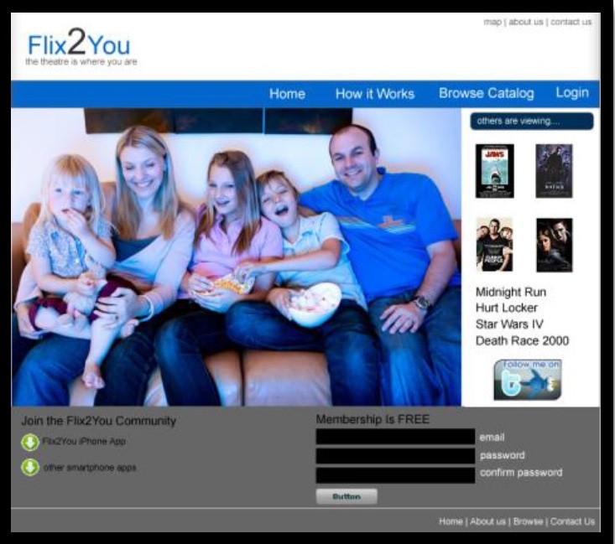

## **Graphic 7.1** – *homepage of the Flix2You website.*

To enable the company to grow larger, it needs to expand on its audience. Limiting to only a few genres of movies, it could alienate a whole demographic of movie-watchers. Within the software, monitoring various genre counts can be easy to read in a simple pie graph. With the following query, we can generate information on how many movies are in each genre:

SELECT genre_type_code, COUNT(*) AS num_movies_per_genre

FROM movies

GROUP BY genre_type_code

ORDER BY num_movies_per_genre DESC;

This query will display the genre_type_code and num_movies_per_genre columns and will be formatted from the highest repeated genre to the lowest. An example pie graph is shown below.

Another possible module of information on the dashboard could include customer information. Suppose a store employee wants to pull up some information about a customer about to purchase a movie. He/she can analyze the chart and see if there are possible impending charges. One simple query to pull up this information would go as follows:

SELECT Customers.customer_last_name, Customers.customer_first_name, Customers.membership_number, Customers.date_became_member, Customers.membership_number, Customer_Rentals.rental_status_code

FROM Customers

FULL JOIN Customer_Rentals

ON Customers.customer_id = Customer_Rentals.customer_id;

One more useful module that would provide some benefit would be a format type module to track which video medium is used the most. This information can be useful to provide a better understanding on what users want. For example, if more people are using Blu-ray discs, and not enough DVDs, we can reduce the quantity of DVDs for future purchases and increase for Blu-Ray discs. An example query that could be involved is as followed:

SELECT format_type_description, COUNT(*) AS num_per_format_type

FROM format_types

GROUP BY format_type_description

ORDER BY num_per_format_type DESC;

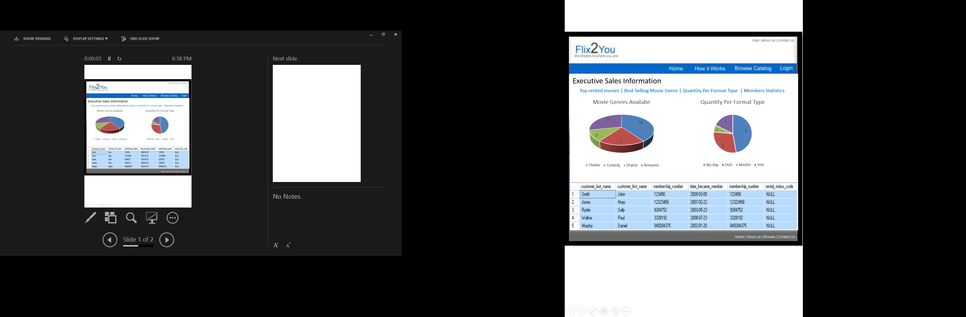

## **Graphic 6.2** - *An example for visual representation of customer information, movie genre, quantity per format type information presented in the dashboard of the website. This page is only accessible by the executive personnel of the company.*

Finally, tracking the number of rentals for the movies is important for making executive inventory decisions. This is because the top rented movies affect the number of movies Flix2You have for sale. Also, if the movies low rental and low sales numbers could be promoted for so that there is resources of the company are utilized effectively. This could be done of adding triggers so that the number of rental could be seen for any movie. Additionally, the webpage would present the option of downloading a pdf or Microsoft excel file of the top rented movie’s list, seen in **Graphic 6.3**.

Queries for determining how often a movie is being rented:

ALTER TABLE Movie_Information ADD num_rentals INT NOT NULL;

CREATE TRIGGER tr_movies_num_rental_add

ON Customer_Rentals FOR INSERT  /*  Where a event is going on */

AS

BEGIN

  UPDATE movies  /* We are updating this table  */

    SET num_rentals = num_rentals + 1 /* increment the number of rental */

    WHERE movie_id = (SELECT movie_id from INSERTED);  /* movie_id being the same in the insert and update table */

END;

SELECT movie_name, num_rental  
FROM Movie_Information

ORDER BY num_rental DESC;

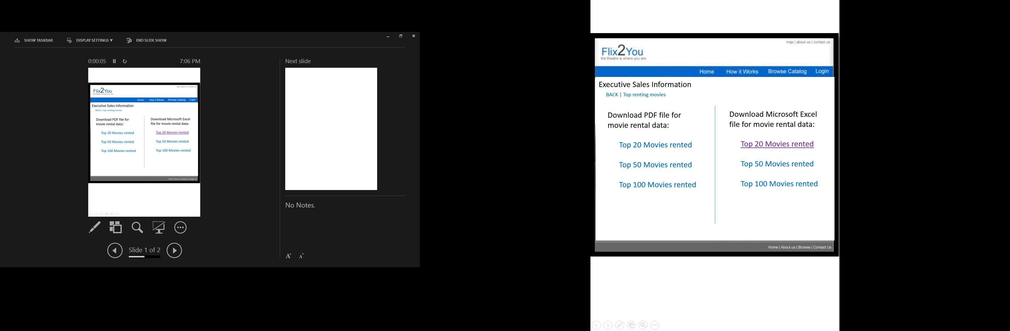

## **Graphic 6.3** – *download page for the sales information of movie rental.*

# **SECTION 8.0 LEGAL ISSUES**

This section will define the suggested Privacy Policy and Terms and Conditions of Use for the Flix2You Company. While this section defines user terms and agreement, the Flix2You Company has the rights to fully define any additional user terms and conditions based on additional company policies.

## **8.1 PRIVACY POLICY**

This Privacy Policy is written to inform all users of this website for Flix2U with information use and security and requires the agreement from the user prior to use with an understanding of the following:

1. Information collected, how it is used and whom it is shared with
2. Choices for the use of data collected
3. Security of data
4. Corrections to personal data

### **8.1.1 Information Collection, Use and Sharing**

Information collected on this site is intended only for business use of Flix2You. Information that is provided is kept private and used only for purposes agreed upon with the user. No information will be sold or distributed outside of the Flix2You Company for any reason not further stated without prior user agreement.

Upon agreement of these terms and conditions, the user agrees to the integrity of personal information provided. The user must be of the age of 18 or above.

If the user wishes to receive further promotional, discounted or special offers from Flix2You as well as any surveys or contests, please be sure to select the option before selecting the Agree or Disagree to this Privacy statement. This option can be removed at any time, but does allow the Flix2You Company to use their email to send this information as well as any changes made to the Privacy Policy (BBB Sample Privacy Policy, n.d.).

All other information collected is used specifically for the Flix2You Company. Information such as credit card number, address and phone number and other listed information are encrypted and protected by our SSL technology.

### **8.1.2 Information Security**

The Flix2You site guarantees that the user information is not shared outside of the user agreement clause. Security measurements align the proper storage and system requirements that ensure data integrity by use of data encryption and SSL (Secure Sockets Layer) security (Protecting Your Financial Transactions, n.d.). If information is misused, misrepresented or illegally discharged the user has the rights to file claims accordingly and the Flix2You Company will investigate and can prosecute based on violations of the Flix2You User Agreement.

### **8.1.3 System Updates**

System maintenance will not affect user information or security therein. Updates are made accordingly and information on updates can be found on site. These updates are to provide system checks, security enhancements and added features.

### **8.1.4 User Registration**

*All users must complete a one-time registration profile upon first purchase from the Flix2You site. This may be done under a guest account if user does not want an active profile. Agreement of Privacy Policy and Terms and Conditions of Use must be completed in addition to the profile creation to complete a First-time purchase transaction. The user understands that the Flix2You Company has the right to update its Privacy Policy and Terms and Conditions of Use at any time which will require a new user agreement to be completed.*

### **8.1.5 Orders**

The Flix2You Company guarantees their services and orders are automatically available for download by the user upon completion of the order (BBB Sample Privacy Policy, n.d.).

## **8.2 TERMS AND CONDITIONS OF USE**

### **8.2.1 REFUNDS**

All purchases are subject to refund upon claims that are deemed refundable. Any refunds made are refunded to the account charged within and up to 14 days upon receipt of all returned rentals. Flix2You reserves the right to decline a claim upon proper investigation

### **8.2.2 CONSEQUENCE OF VIOLATIONS**

Falsifying information for credit transaction is unacceptable and will not be tolerated. All charges are subject to authorization (Goodale, 2014). Any unlawful action therein thus justifies the rights of the Flix2You Company to file a claim.

If the user does not wish to agree to the policy, terms and conditions and user agreement therein, the user automatically waives the rights of services provided by the Flix2You Company.

# **SECTION 9.0 REFERENCES**

1. The Theatre is Where You Are. (n.d.). In *Flix2You*. Retrieved September 15, 2015, from <http://www.personal.psu.edu/fja100/flix2you/>
2. SQL ALTER TABLE Statement. (n.d.). In *W3Schools.com*. Retrieved December 11, 2015, from <http://www.w3schools.com/sql/sql_alter.asp>
3. SQL AUTO INCREMENT Field. (n.d.). In *W3Schools.com*. Retrieved December 11, 2015, from <http://www.w3schools.com/sql/sql_autoincrement.asp>
4. SQL INSERT INTO Statement. (n.d.). In *W3Schools.com*. Retrieved December 11, 2015, from <http://www.w3schools.com/sql/sql_insert.asp>
5. (n.d.). In *MicroStrategy*. Retrieved December 11, 2015, from <http://www.microstrategy.com/us>
6. BBB Sample Privacy Policy. (n.d.). In *BBB Start With Trust*. Retrieved October 20, 2015, from <https://www.bbb.org/dallas/for-businesses/bbb-sample-privacy-policy1/>.
7. Protecting Your Financial Transactions. (n.d.). In *Internet Safety*. Retrieved November 8, 2015, from <http://www.gcflearnfree.org/internetsafety/6/print>.
8. Goodale, D. (2014, March 27). Understanding Credit Card Pre-Authorizations. In *merchant account.ca*. Retrieved November 8, 2015, from <https://www.merchant-accounts.ca/understanding-credit-card-pre-authorizations.php>.
9. Andress, J. (2014). Network Security. In The basics of information security understanding the fundamentals of InfoSec in theory and practice (2nd ed.). Waltham, MA: Syngress.
10. Andress, J. (2014). Authorization and Access Control. In The basics of information security understanding the fundamentals of InfoSec in theory and practice (2nd ed.). Waltham, MA: Syngress.